Homework 3 Part 1

1. Host A will have a source port of 26145 and destination port 80, while Source B to A will have source port 80 and destination 26145, and with host c, it will be 7532 to 80, and B to C will be 80 to 26145 and 7532.
   1. the ip addresses will be set according to if it is coming to/from the host A or B.
2. 01010011+ 01100110 = 10111001 + 01110100 = 00101110 -> 11010001
   1. it takes the compliment to check for errors the words and the checksum
   2. if the sum has a zero, then we know there is an error.
   3. We can detect all one bit errors, but not all 2 bit errors
   4. If the first word is 0 and the last digit of the second word is 1

25. a. UDP includes data as part of its payload in a UDP segment. TCP may get the bytes, but it might not put it in a tcp segment

b.UDP does not have delays because of the flow control and congestion control. TCP could have delays from writing the data, sending to data and when the data is put on network layer.

27. a) source port: 302, destination port: 80, sequence number:207

b) source: 302, desitnaiton: 80, sequence:207

c) the ack number is 127 meaning that it’s still waiting for the first segment

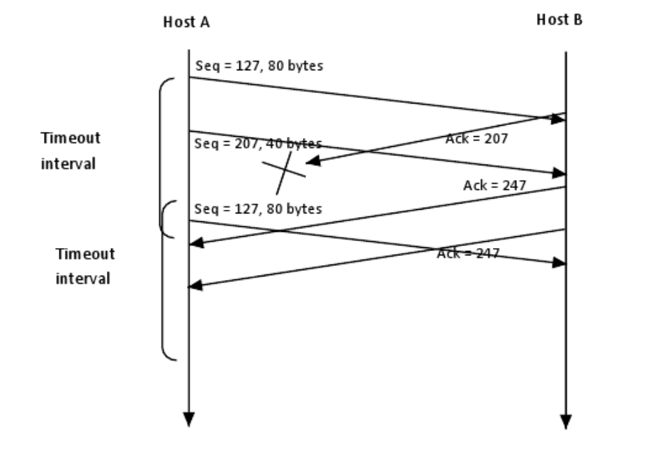

33) Those segments have the same data and sequence numbers are previous ones. When we receive certain acks from the receiver, it is trivial whether or not they were response to the previous tcp segment or to the transmitted segments. If we do retrieve an ack for the data segment wet sent again, it would be a late ack and would cause a faster retranmission and worser network traffic